EXP 12

AIM: Design DFA using simulator to accept the input string “a” ,”ac”,and ”bac”.

INPUT:

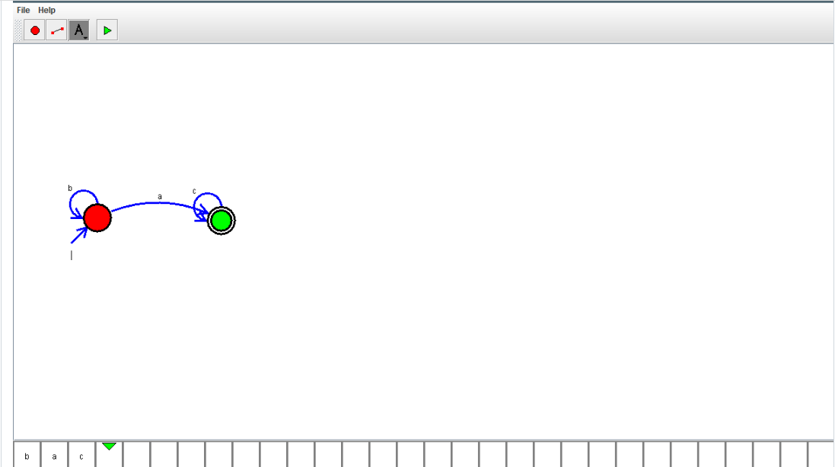

OUTPUT:



RESULT: DFA using simulator to accept the input string “a” ,”ac”,and ”bac” Is verified successfully